**Formulas and Derivation for stereo camera rig**

Projection Equations

(1)

(2)

where X, Y, and Z are coordinates in the scene and x and y are image coordinates.

Differentiate to get optical flow (also can be done geometrically page 110):

(3)

(4)

(4)

(5)

(6)

(7)

(8)

(9)

(10)

(11)

(12)

For a discrete implementation with cameras with different focal lengths and at different distances from the scene:

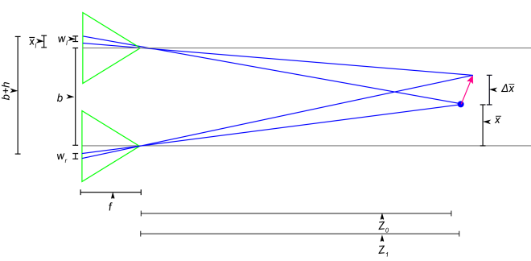

(13)

(14)

(15)

(14)

where:

(14)

is the baseline, and

(14)

is the disparity. Solving for the optical flow:

(15)

(15)

reducing gives:

(15)

(15)

which compares to ? except with the reversed sign because I defined my axes differently

(21)

or

(23)

and are related by:

(25)

(26)

(27)

(28)

(29)

(30)

(31)

We find or using the following energy equation along a radial line:  
 (32)

(33)  
 (34)

Once we have the estimate for h and Z we can compute W from equation (9) or (10) as follows:

(35)

(36)

QED